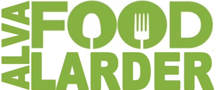
Rota
Jan-April 2026
Fridays 11.30 – 3.15pm

Jan | Feb | March | April
2  Steve  Ka | 6  John K  Ann M | 6  Gil  Jan | 3  Steve  Ann M
9  John L  Joyce | 13  Steve  Freda | 13  Sam  Joyce | 10  James  Freda
16  Gil  Jan | 20  James  Elaine | 20  John K  Rose | 17  Sam  Elaine
23  Sam  Rose | 27  John L  Kay | 27  John L  Liz | 24  Gil  Jan
30
James
Liz

